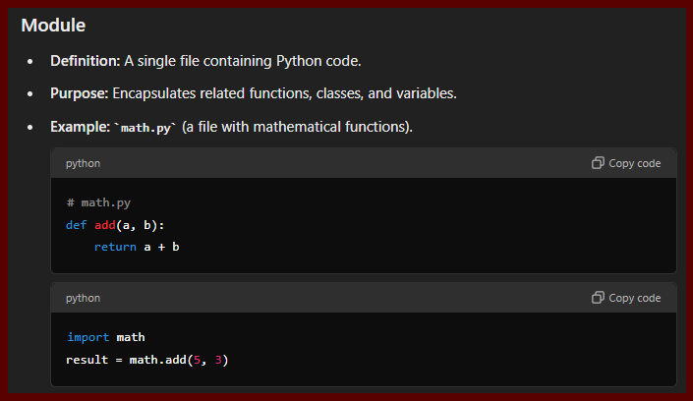

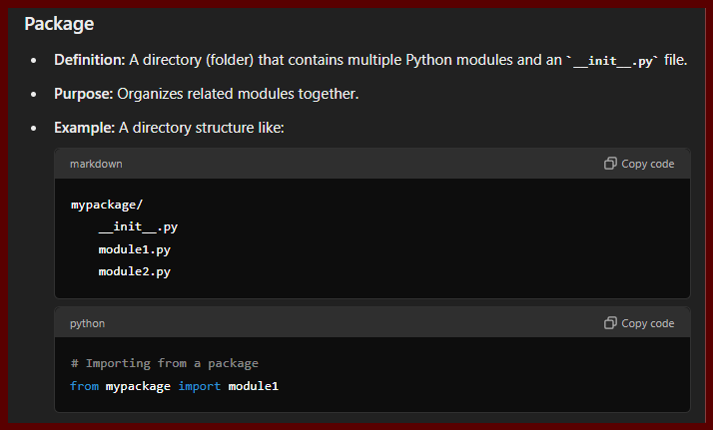

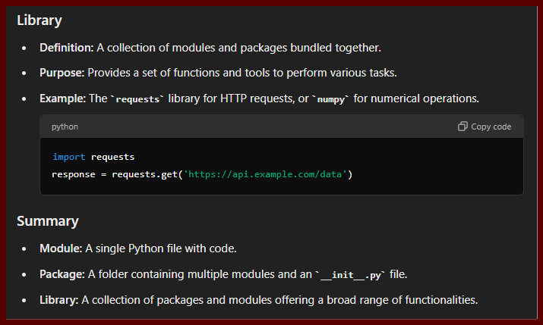

* Created a virtual environment
* “pip install virtualenv” //installing package to create a virtual Env.
* “virtualenv myEnv” // creating a V Environment named “myEnv”.
* “.\myEnv\Scripts\Activate.ps1” // Started Env. To work on.
* Installing
* “pip install speechrecognition pyaudio” //installed 2 packeges using this.
* “pip install setuptools” //
* “Pip install pyttsx3” // for text to speech from system to us.
* webbrowser Module // Inbuit Module
* 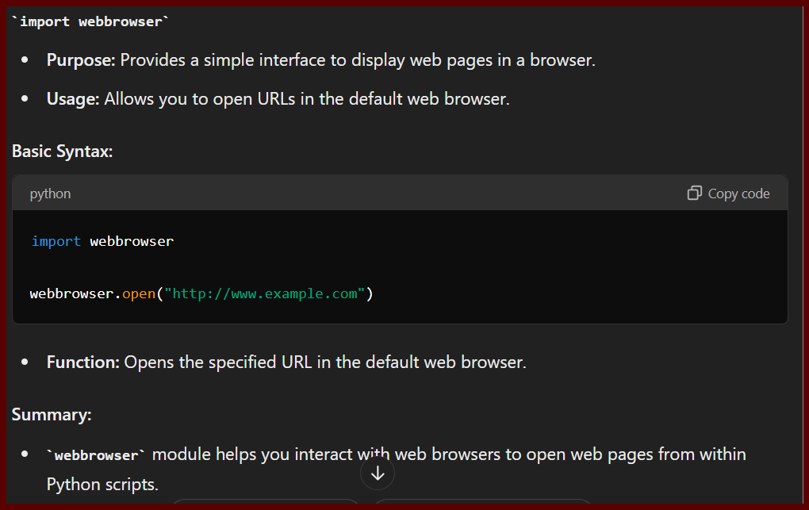
* 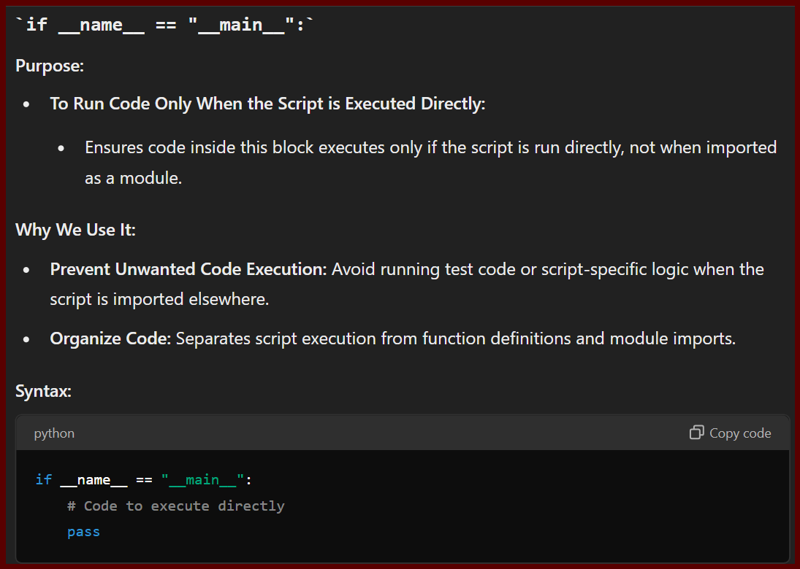

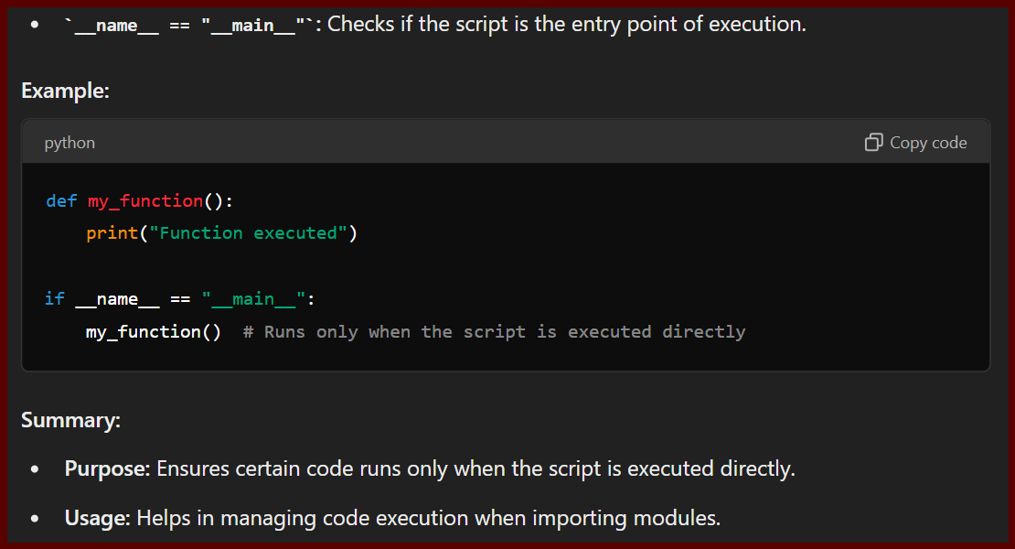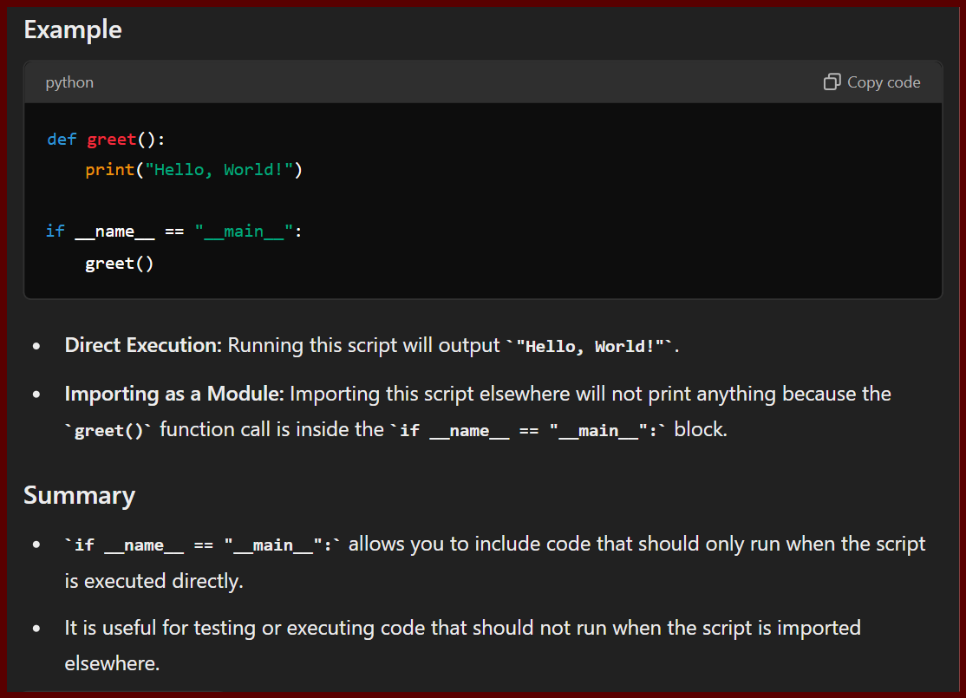

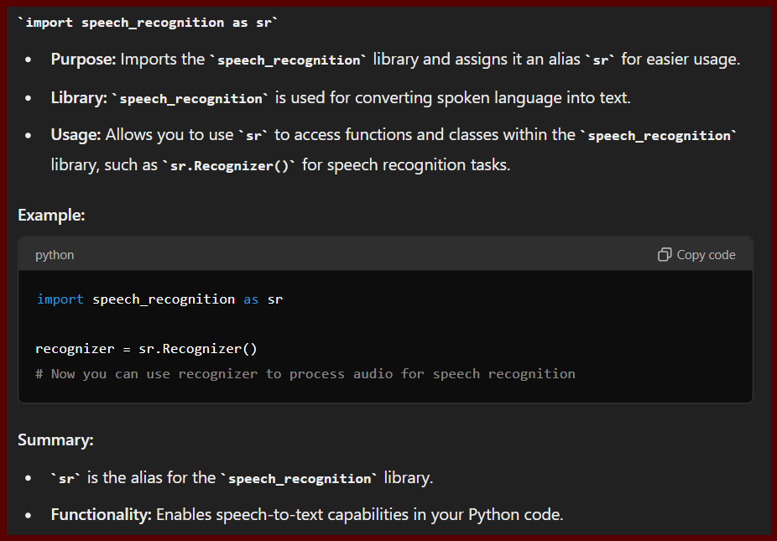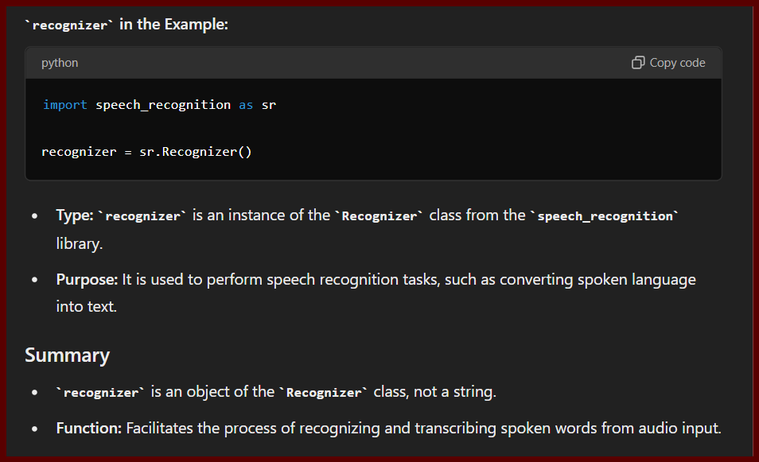

* Create:- recognizer object to store whatever we spoke in it.
* recognizer_obj = sr.Recognizer()

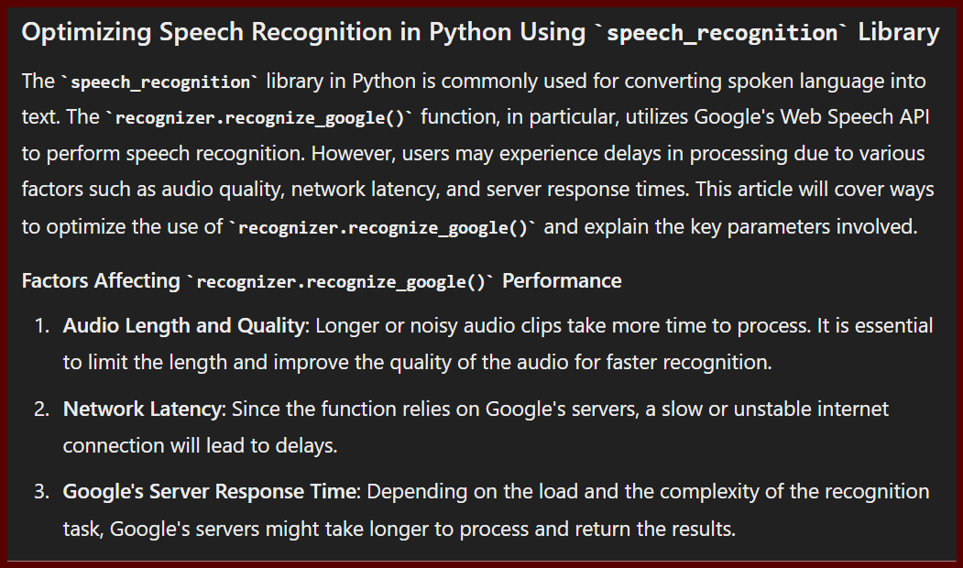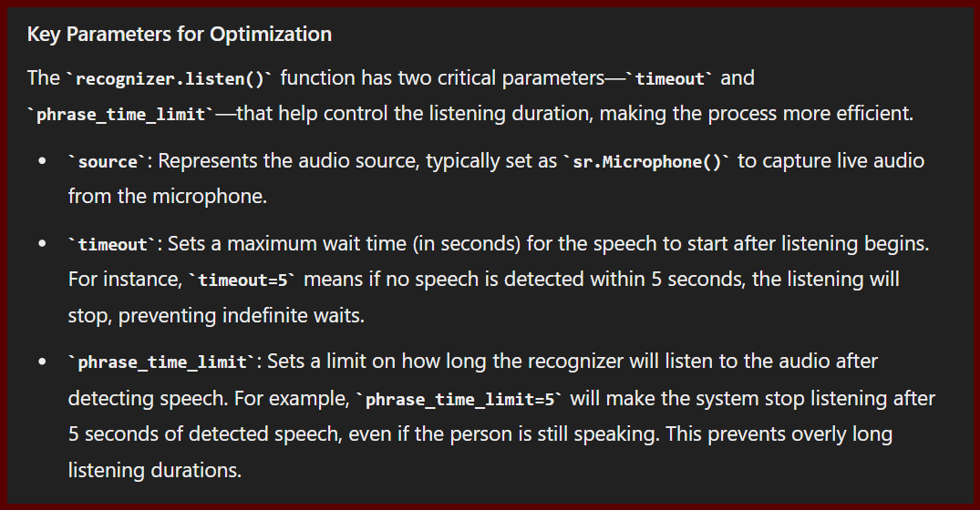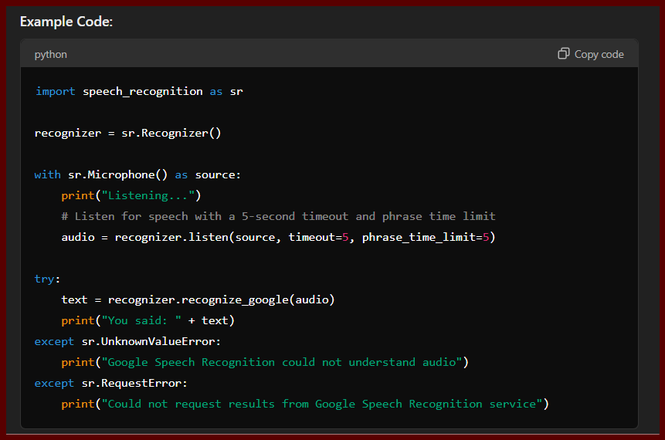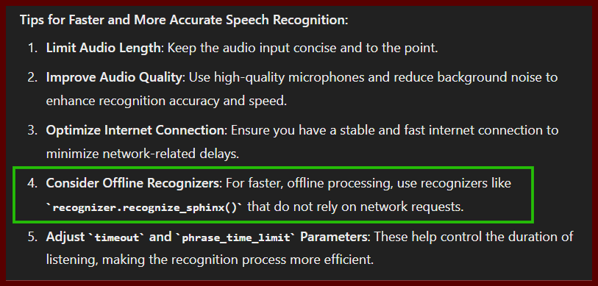

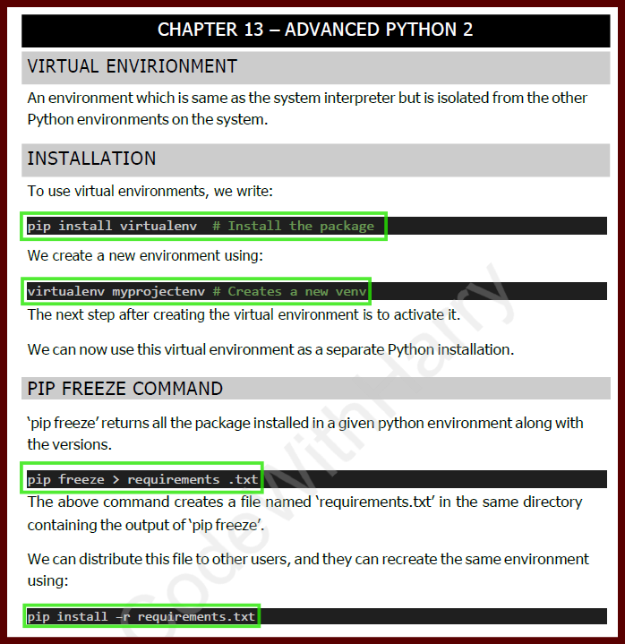

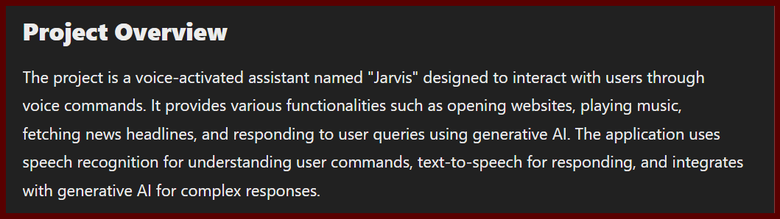

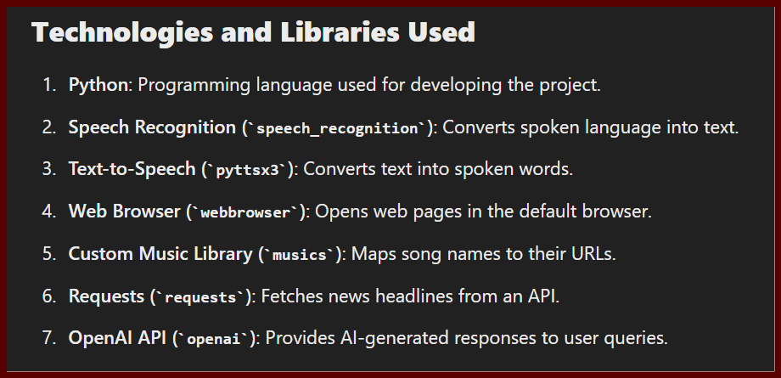

**Python**:

* **Type**: Programming Language
* **Description**: The primary language used for developing the assistant.

**Speech Recognition (Library)**:

* **Type**: Library
* **Description**: Converts spoken language into text. It handles voice input from the user.

**Pyttsx3 (Library)**:

* **Type**: Library
* **Description**: A text-to-speech library that converts text into spoken words. It is used for generating audio responses.

**Webbrowser (Library)**:

* **Type**: Library
* **Description**: Provides a simple interface to open web pages in a browser. Used to navigate to websites based on user commands.

**Musics (File)**:

* **Type**: Custom Python File
* **Description**: A Python file that contains a dictionary mapping song names to their respective URLs. This is used to play music based on user requests.

**Requests (Library)**:

* **Type**: Library
* **Description**: Used for making HTTP requests. In your project, it fetches news headlines from an API.

**OpenAI (Library)**:

* **Type**: Library
* **Description**: Provides access to OpenAI's generative models for AI-based responses. This library is used to interact with the OpenAI API.

**OpenAI API**:

* **Type**: Service
* **Description**: An online service that provides various AI capabilities, including text generation and completion.

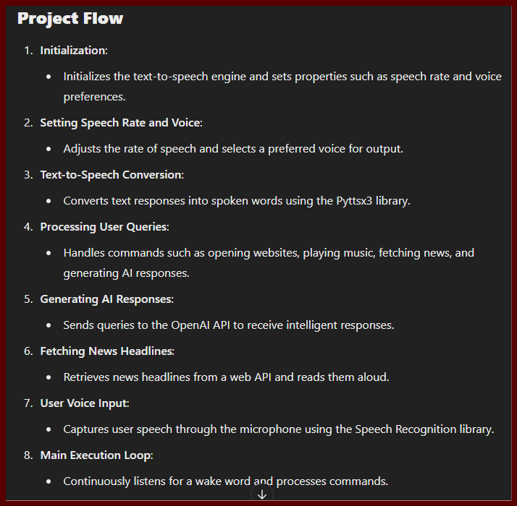

**Challenges Encountered/Learnings**

1. **API Key Issues**:
   * **Challenge**: Properly setting up and using API keys for services like OpenAI. There are two main methods:
     + **Environment Variable**: This involves storing the API key in an environment variable, a secure method to keep sensitive information. You can then access this key in your code without hardcoding it directly.
     + **Client Configuration**: Here, you pass the API key directly when configuring the client object in your code.
   * **Solution**:
     + **Environment Variable**: Ensured the API key was set correctly in the system's environment variables and accessed in the code using os.environ.
     + **Client Configuration**: Made sure the API key was correctly passed when initializing the client object, avoiding hardcoded keys and ensuring secure handling.
2. **Speech Recognition Timeouts**:
   * **Challenge**: The system sometimes failed to recognize speech due to timeouts or errors.
   * **Solution**:
     + Implemented error handling and retry mechanisms to keep the system functional during temporary issues.
     + Used parameters like “timeout” and “phrase_time_limit” to adjust the listening behavior: audio = recognizer.listen(source, timeout=1, phrase_time_limit=3).
     + Added a while loop to keep the program running indefinitely until the user says "close yourself," which triggers the exit() function to stop the program.
     + Improved voice configuration for clearer and more reliable speech recognition.
3. **Voice Output Consistency**:
   * **Challenge**: Ensuring that the voice output was clear and at the correct playback speed.
   * **Solution**:
     + Adjusted the settings for speech rate and voice type using pyttsx3 to ensure the responses were understandable and consistent.
     + Changed the default voice from Microsoft David Desktop to Microsoft Zira Desktop for better clarity.
     + Initially used Google’s gtts for an Alexa-like voice but encountered limits on the number of requests allowed (the free tier typically allows up to 500 requests per day).
4. **API Usage Limits**:
   * **Challenge**: Exceeding the request limits for OpenAI’s API, which led to interruptions in service.
   * **Solution**:
     + Explored alternatives like Google’s GenAI API to handle requests when the OpenAI limit was exhausted.
     + Managed API requests more efficiently to avoid hitting the usage limits.
5. **Handling Programming Events**:
   * **Challenge**: Managing unexpected stops in the program due to errors, such as issues with speech recognition and API requests.
   * **Solution**:
     + Added comprehensive error handling to manage different error scenarios (e.g., WaitTimeoutError in speech recognition).
     + Implemented mechanisms to catch errors, display informative messages to users, and retry operations when necessary to ensure continuous operation.

